Colour is a powerful Design Element that can significantly influence human emotions, behaviours, and cultural perceptions. In interior design, the psychological impact can be felt in both positive and negative ways. Along with enhancing the functionality and aesthetics of a space, colour can also affect the biological functions of the users, as well as their moods, making a space more appealing and suitable for its intended use. Understanding the psychological and cultural impact of colour is a valuable tool for designers to possess when creating environments that can impact the user on a deeper level.

Below we will look at how warm and cool colours can affect the user of a space in different ways. We will also look at how colour is used in the industry and how we can “read” whether a colour scheme is warm or cool, without actually using the “standard” colours perceived to be warm or cool.

## Impact on Mood and Perception

The psychological impact of colour refers to the way different colours can affect our mood, feelings, and overall mental state. Colour can also affect our perception of a room, making it feel warmer or cooler in temperature. As users, this can affect the way our bodies react to this perception of the temperature of a space.

Here are some key insights into the psychosomatic (psychological and biological) effects of various colours:

#### Red:

Psychosomatic impact: Red is a stimulating colour that evokes strong emotions. It can increase energy levels, excitement, and passion. However, it can also trigger feelings of anger and aggression if overused.

Usage: Ideal for dining rooms and social spaces where energy and interaction are desired. Use in moderation to avoid overwhelming the space.

#### Orange:

Psychosomatic Impact: Orange is associated with enthusiasm, creativity, and warmth. It can make a space feel welcoming and lively.

Usage: Suitable for living rooms, kitchens, and playrooms. It encourages socialisation and activity.

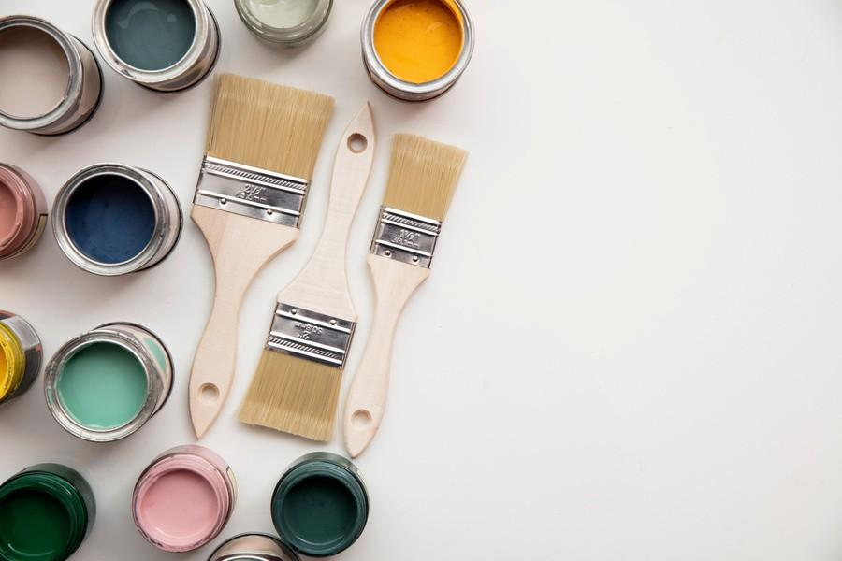

Fig. 1. Canva (n.d.), Paint pots in various colours with paint brush

#### Yellow:

Psychosomatic Impact: Yellow evokes feelings of happiness, optimism, and warmth. It can uplift spirits and create a cheerful atmosphere.

Usage: Great for kitchens, bathrooms, and hallways. Use softer shades to avoid overstimulation.

#### Blue:

Psychological Impact: Blue has a calming effect, promoting relaxation and tranquillity. It can lower stress levels and create a sense of serenity.

Usage: Perfect for bedrooms, bathrooms, and study areas. Light blues can make a room feel spacious, while darker blues add cosiness.

#### Green:

Psychosomatic Impact: Green symbolises nature, balance, and renewal. It is soothing and can enhance concentration and stability.

Usage: Suitable for almost any room, especially bedrooms, living rooms, and offices. It brings a touch of nature indoors.

#### Purple:

Psychosomatic Impact: Purple combines the stability of blue and the energy of red. It can evoke feelings of luxury, creativity, and calm.

Usage: Light purples (lavender) are ideal for relaxation spaces like bedrooms. Darker purples (eggplant) can add sophistication to living rooms and dining areas.

#### White:

Psychosomatic Impact: White represents purity, cleanliness, and simplicity. It can make spaces feel open and airy, but can also appear sterile if overused.

Usage: Ideal for creating a sense of space and light. Use in combination with other colours to add warmth and personality.

#### Grey:

Psychosomatic Impact: Grey is neutral, sophisticated, and balanced. It can evoke feelings of calm and composure, but might feel dull if not balanced with other colours.

Usage: Works well in modern and minimalist designs. Pair with brighter accents for a more dynamic look.

#### Black:

Psychosomatic Impact: Black symbolises elegance, power, and sophistication. It can add depth and contrast but can make a space feel dark if overdone.

Usage: Can be used as an accent colour to add drama and focus, but also as an effective base to create a sense of continuity. It can be effective in small doses, for features and highlights, or can hide extreme shadows on walls, in larger surface areas.

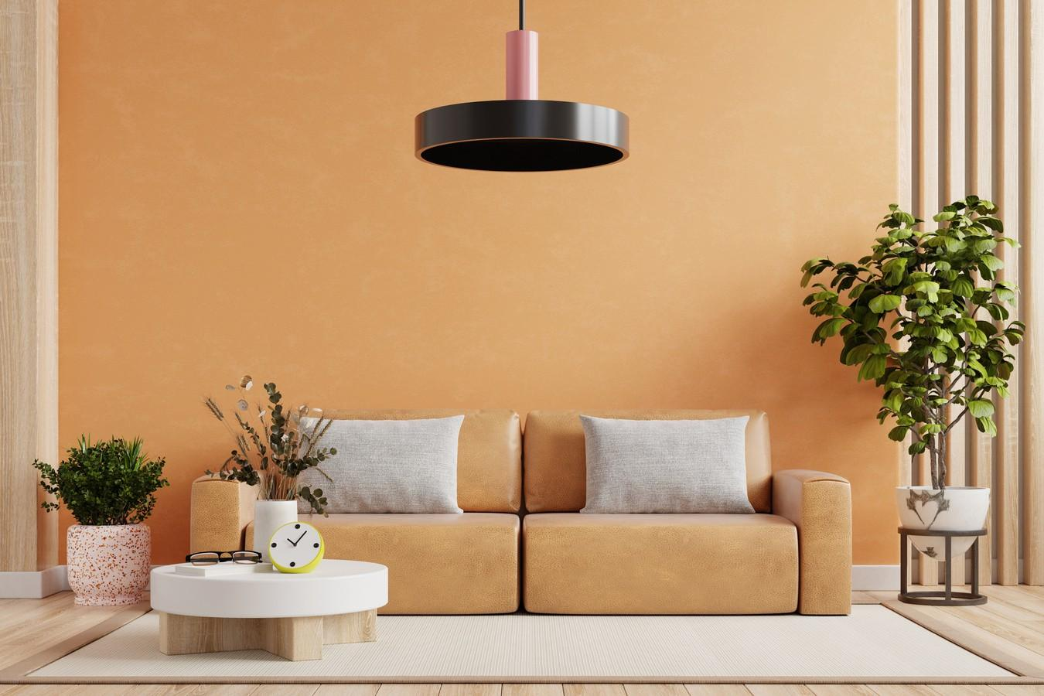

Fig. 2. Canva (n.d.), Bright and cosy living room

## Cultural Impact of Colour

Cultural impact refers to the various meanings and the significance attributed to colours across different cultures. Here’s a look at how some colours are perceived in cultural contexts:

**Red**:

Western Cultures: Often associated with love, passion, and danger.

Eastern Cultures: In China, red symbolises good fortune, joy, and celebration. It is prominently used in festivals and weddings.

#### Blue:

Western Cultures: Represents calmness, stability, and trust. Commonly used in corporate settings.

Middle Eastern Cultures: Blue is considered protective, and is often used in spiritual and decorative contexts to ward off evil spirits.

#### Yellow:

Western Cultures: Conveys happiness, optimism, and warmth.

Asian Cultures: In many Asian cultures, yellow is a sacred and imperial colour, particularly in China where it represents royalty and power.

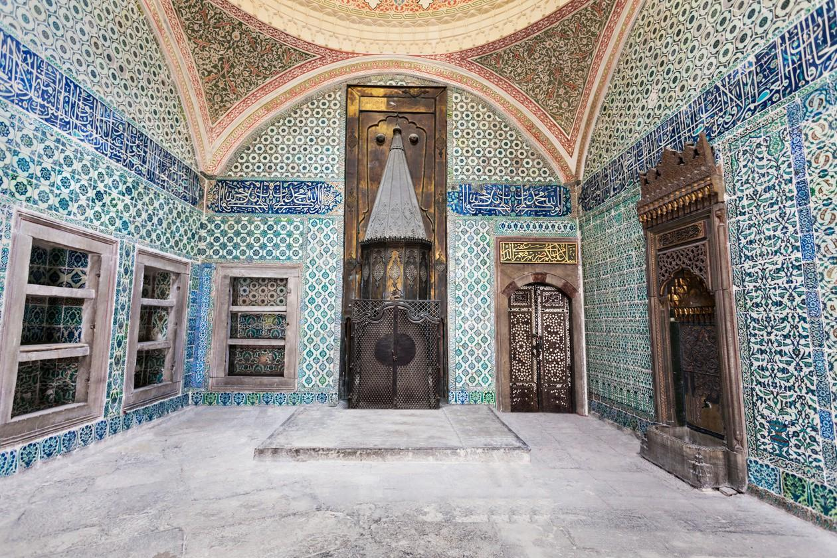

Fig. 3. Canva (n.d.), Interior of Middle Eastern Temple

#### Green:

Western Cultures: Symbolises nature, growth, and tranquillity.

Islamic Cultures: Green is a sacred colour in Islam, representing paradise and prosperity.

#### White:

Western Cultures: Associated with purity, cleanliness, and peace. Often used in weddings. Eastern Cultures: In many Asian cultures, white is associated with mourning and funerals.

#### Black:

Western Cultures: Often linked to elegance, sophistication, and mourning.

African Cultures: In some African cultures, black symbolises maturity, masculinity, and leadership.

# Practical Applications in Interior Design

#### Designing for Emotional Impact:

Relaxation Spaces: Use calming colours like blue and green in bedrooms and bathrooms to promote relaxation and tranquillity.

Energetic Spaces: Employ warm, vibrant colours like red, orange, and yellow in areas intended for social interaction and activity, such as living rooms and kitchens.

#### Cultural Sensitivity:

Cultural Appropriateness: When designing for clients from different cultural backgrounds, consider the cultural meanings of colours to ensure the space is respectful and appropriate.

Festive and Ceremonial Spaces: Use culturally significant colours for festive or ceremonial spaces to enhance their cultural resonance.

#### Balancing Colour Schemes:

Neutral Bases: Use neutral colours like white, grey, and black as a base to balance more vibrant colours. This approach can create a cohesive and sophisticated look.

Accent Colours: Incorporate accent colours to highlight specific features, and create focal points. Ensure these accents align with the desired emotional and cultural impact.

#### Personalised Spaces:

Client Preferences: Always consider the personal preferences and emotional responses of the clients. Customising colour schemes to suit individual tastes can make a space feel more personalised and comfortable.

The psychological and cultural impacts of colour are integral to effective interior design. By understanding how different colours affect emotions, and how they are perceived in various cultures, designers can create spaces that are not only aesthetically pleasing but also emotionally supportive and culturally appropriate. Whether designing for relaxation, energy, or cultural significance, the strategic use of colour can transform a space and enhance the overall experience of its occupants.